WARRAGAMBA PUBLIC SCHOOL

Civic Centre Phone: 4774 1205
WARRAGAMBA PUBLIC SCHOOL
WARRAGAMBA PUBLIC SCHOOL
WARRAGAMBA PUBLIC SCHOOL
WARRAGAMBA PUBLIC SCHOOL
2-4 Fourth Street Fax: 4774 2475
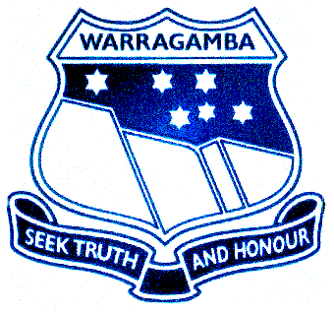
(PO Box 19) Email: warragamba-p.school@det.nsw.edu.au
Warragamba 2752

Dear Parents,

A case of head lice has been found in your child’s classroom today. Could you please check your child’s hair to make sure head lice are not present.

Signs and symptoms:

- Itching of the scalp-especially toward the back of the neck or behind the ears
- Rash caused by scratching
- White specks (the eggs) stuck to hair that do not fall out when touched
- Lice can be passed onto others
- All eggs must be removed before your child returns to school as the cycle repeats itself if eggs are present.

Treatments are available from your local pharmacy or specialty shampoo shop. Applying a white hair conditioner to dry hair and combing through with a fine toothed comb will lift the eggs from the hair.

If you have any concerns or queries, please do not hesitate to contact the office on 4774 1205.

Thank you
Mrs Karina Shepherd
Principal

